**ASSIGNMENT NO. 7**

**Title**: Assignment on Classification technique

Every year many students give the GRE exam to get admission in foreign Universities. The data set contains GRE Scores (out of 340), TOEFL Scores (out of 120), University Rating (out of 5), Statement of Purpose strength (out of 5), Letter of Recommendation strength (outof 5), Undergraduate GPA (out of 10), Research Experience (0=no, 1=yes), Admitted (0=no, 1=yes). Admitted is the target variable.

Data Set: https://www.kaggle.com/mohansacharya/graduate-admissions

The counselor of the firm is supposed to check whether the student will get an admission or,not based on his/her GRE score and Academic Score. So to help the counselor to take appropriate decisions, build a machine learning model classifier using a Decision tree to predict whether a student will get admission or not.

1. Apply Data pre-processing (Label Encoding, Data Transformation....) techniques if necessary.
2. Perform data-preparation (Train-Test Split)
3. Apply Machine Learning Algorithm
4. Evaluate Model.

**S/W Packages and H/W apparatus used:** Linux OS: Ubuntu/Windows ,

Jupyter notebook.

**Theory/Methodology:**

**Classification:**

Classification is a process of categorizing a given set of data into classes, It can be performed on both structured or unstructured data. The process starts with predicting the class of given data points. The classes are often referred to as target, label or categories.

What is a Decision Tree?

It uses a flowchart like a tree structure to show the predictions that result from a series of feature-based splits. It starts with a root node and ends with a decision made by leaves.

Root Nodes – It is the node present at the beginning of a decision tree.

From this node the population starts dividing according to various features.

Decision Nodes – the nodes we get after splitting the root nodes are called

Decision Node

Leaf Nodes – the nodes where further splitting is not possible are called leaf nodes or terminal nodes

Sub-tree – just like a small portion of a graph is called sub-graph similarly a subsection of this the decision tree is called a sub-tree.

Pruning – It is cutting down some nodes to stop overfitting

Entropy:

Entropy is used to calculate the homogeneity of a sample. If the sample is completely homogeneous the entropy is zero and if the sample is equally divided it has entropy of one.

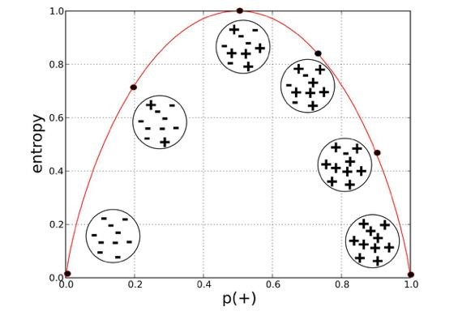

1. Entropy using the frequency table of one attribute:

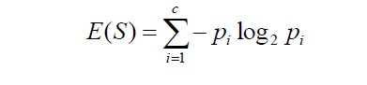

1. Entropy using the frequency table of two attributes:

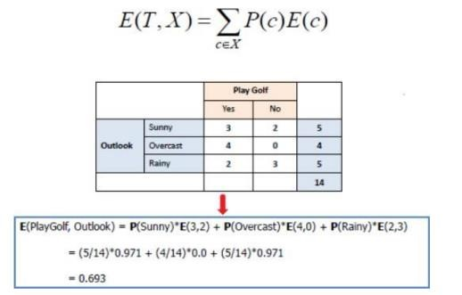

**Information Gain**

The information gain is based on the decrease in entropy after a dataset is split on an attribute.

**Constructing a decision tree**

IS all about finding attributes that return the highest information gain (i.e., the most homogeneous branches)

Step 1: Calculate entropy of the target.

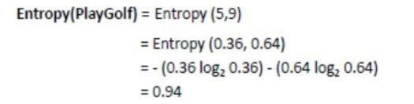

Step 2: The dataset is then split on the different attributes. The entropy for each branch is calculated.

Then it is added proportionally, to get total entropy for the split. The resulting entropy is subtracted from the entropy before the split. The result is the Information Gain, or decrease in entropy.

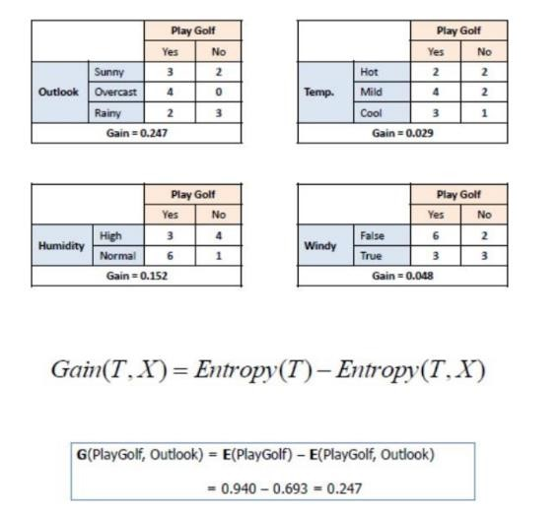

Step 3: Choose the attribute with the largest information gain as the decision node, divide the dataset by its branches and repeat the same process on every branch.

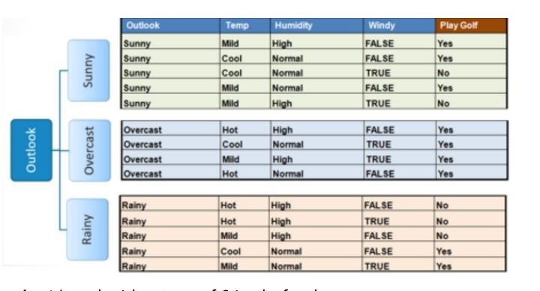

Step 4a: A branch with entropy of 0 is a leaf node.

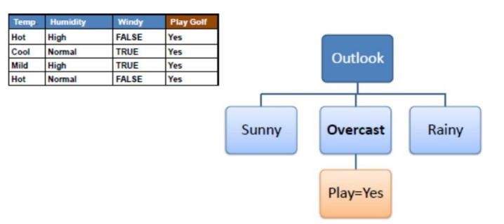

Step 4b: A branch with entropy more than 0 needs further splitting.

Step 5: The ID3 algorithm is run recursively on the non-leaf branches, until all data is classified.

**Advantages:**

* Decision Trees are easy to understand and interpret.
* They can handle both numerical and categorical data.
* Decision Trees implicitly perform feature selection.

**Limitations:**

* Decision Trees are prone to overfitting, especially with complex datasets.
* They may not perform well with imbalanced datasets.

**Conclusion:**

Classification techniques help in classifying problems and helps figure out relationship between the various variables. By applying a Decision Tree classifier to the admission data, we can predict whether a student will get admission based on their academic scores. Decision Trees offer a simple and interpretable solution for classification tasks. However, it's essential to evaluate the model's performance and consider potential limitations such as overfitting. Additionally, feature selection and data preprocessing play crucial roles in improving the accuracy and generalization of the model.